Direct Entry Admissions Guide
Accessing the Admissions Portal – First time users and registration
- You will be sent a link to the web page you need to use to apply for your programme. When you follow the link you will see the following page:
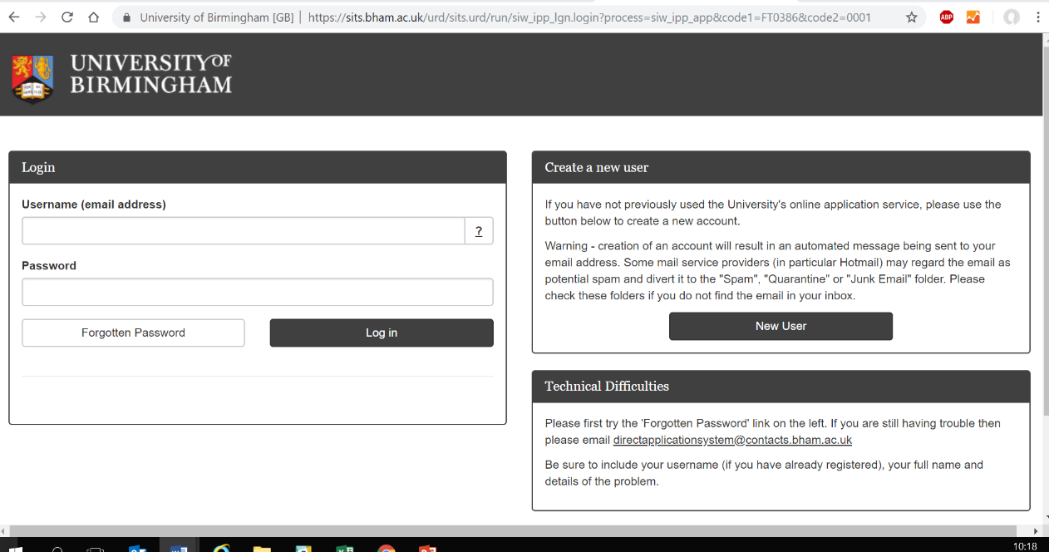

The first thing you will need to do is to create a new account. To do this, click “New User”
- Complete the mandatory details in the following screen:
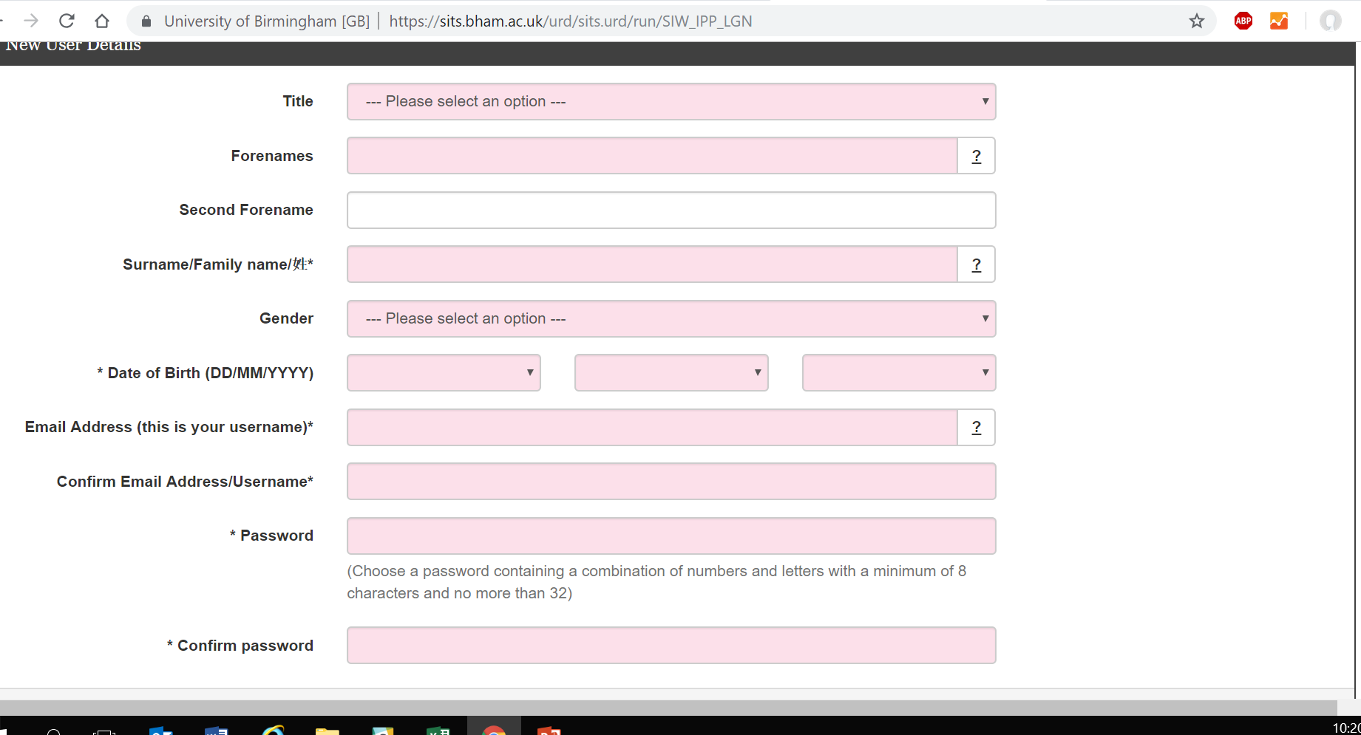

- Ensure you remember the email address and password that you have used as this will be your log in details.
- Once you have completed the form, click “Proceed”
- You will be automatically returned to the application form.
- You will also receive a “Registration confirmation” email to the email address entered in the above screen. Please check your “Junk” and “SPAM” folders as it may have been sent to this folder.

Starting your application
- You will see the following page – ensure that the programme details that you wish to apply for under “Course Application” are correct. If they are not correct, do not proceed with your application, and instead, check with your home University who will send you the correct link to apply for your programme.

- Please ensure that you have your institutional letter of recommendation available to upload – you will not be able to submit the form without this document.
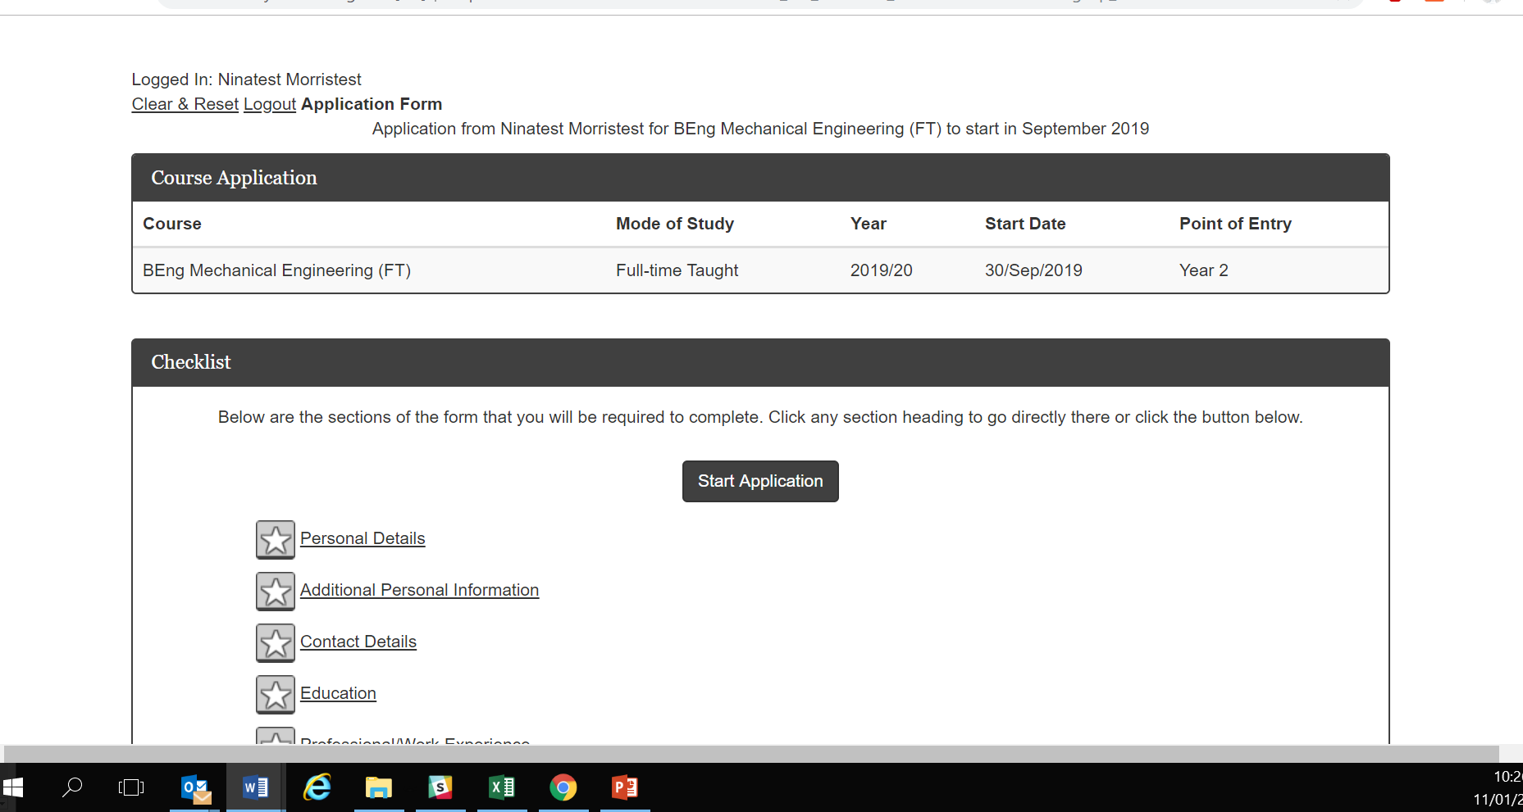
- Click on “Start Application”. You will be taken to the “Personal Details” section of the form.

Personal Details

- Please complete the relevant sections of the form. Any questions with an asterisk (*) must be completed.

Additional Personal Information

- Please complete the relevant sections of the form. Any questions with an asterisk (*) must be completed. If a section does not have an asterisk (*) and it is not relevant, you do not need to complete it.
Contact details
- Please complete the relevant sections of the form. Any questions with an asterisk (*) must be completed.

- On the “Agent/Partner Institution” Section of the form, it is ESSENTIAL that you complete both sections 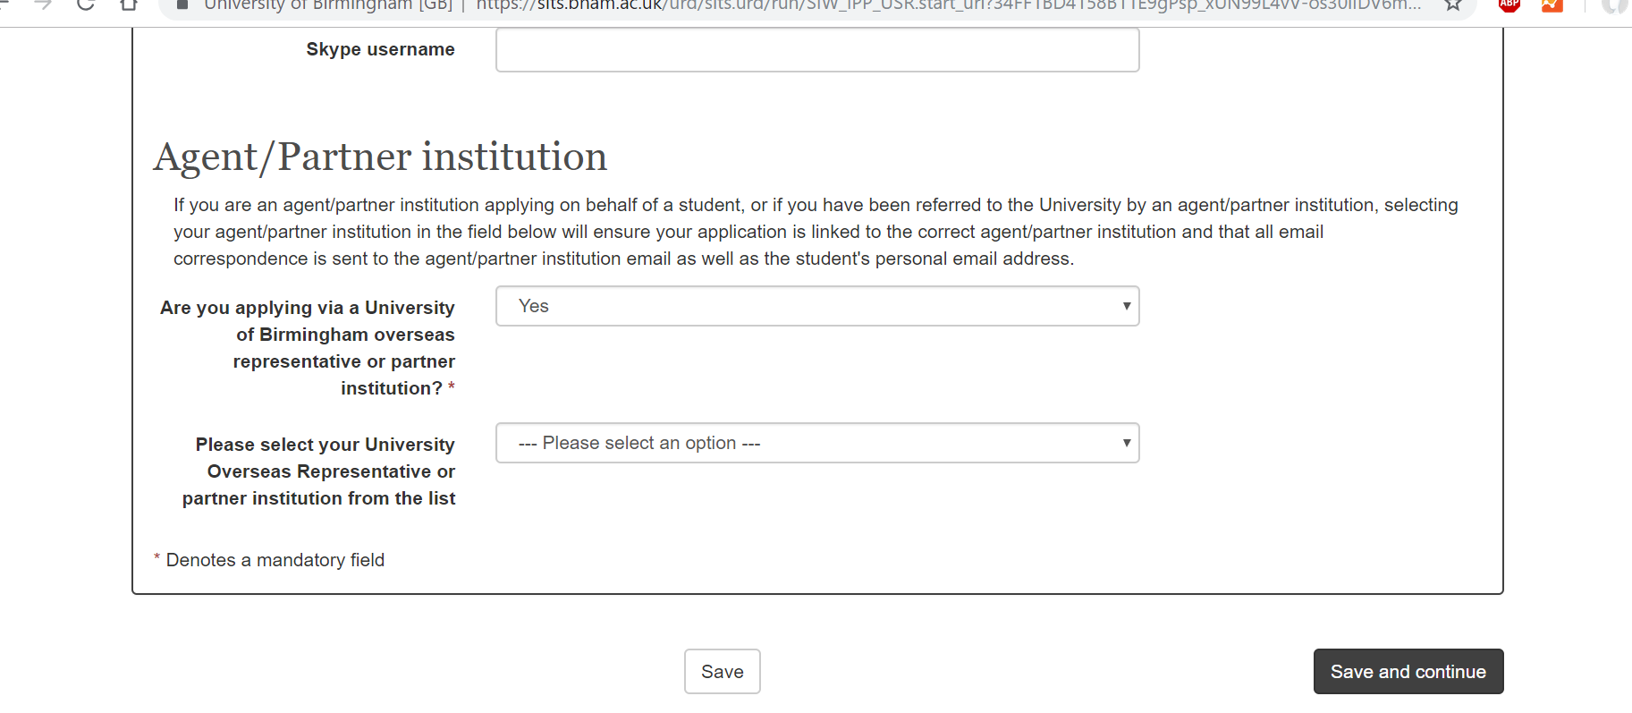

- Under the section: “Are you applying via a University of Birmingham overseas representative or partner institution, select “Yes”.

- Under the section “Please select your University Overseas Representative or partner institution from the list, you will need to scroll down to close to the list and select “Partner Institution” – and then the name of your current University.

- If you do not complete this section, this will cause delays with your application being processed, therefore it is essential that you complete this section accurately.

Education
- Please complete the relevant sections of the form. Any questions with an asterisk (*) must be completed.
- Academic Qualification 1
  - Ensure you enter the details from your current university.
  - In the “subject” section, please choose the subject in your home university that most closely matches your current subject that you are studying.
  - In the “Attended From” section, please complete the dates that you commenced your programme of study at your home institution. In the “Attended to” section, please complete the date when you expect to graduate.
  - Under “Completed” – select “no”.

- Documents
  - Your home university will need to upload your final transcript (and English language translated version) once it is available, via the partner portal, in order for it to be verified by our Admissions Office. Please do not upload your transcript at this stage.

- English Language Qualification
  - Complete all mandatory sections.
  - For the question “Are you a national from a majority English speaking country as defined by UKVI” select “No”.

Professional/Work Experience

- Documents
  - This section is optional - you are not required to complete this section
- Work Experience
  - This section is optional - you are not required to complete this section
- Professional or other qualifications
  - This section is optional – you are not required to complete this section

Personal Statement

- This section is optional – you are not required to complete it.

Passport

- Please complete all mandatory sections and upload a copy of the photographic page of your passport
- Previous Study UK
  - This section is optional – you are not required to complete this section

Referees

- Under “Do you have a reference to upload”, select “yes”, and upload your intuitional letter of recommendation. Please note, you will not be able to submit your application until this document has been uploaded.

Application Information
- Under “Documents”, please upload a list of modules currently being studied this semester

Submission
- Before submitting, please check that you have submitted all the documents that you want to submit at this stage. Please note that you will not be able to change your application once you have submitted it, however you will be able to log in to submit additional supporting documents.
- Data protection statement
  - Please tick the box to confirm that you understand and agree to the statement
- Declaration
  - Please tick the box to confirm that you understand and agree to the statement
- Once you have completed your application, please click “Submit”. If you have not completed any of the compulsory sections, you will need to complete these before you can submit.
- Once you have submitted you will receive an email confirmation, and a link to the portal, which you can then use to upload further documents in the future: https://pga.bham.ac.uk/portal
Adding additional documents through the portal
- Once you have submitted your application, you can add additional documents to your application by visiting: https://pga.bham.ac.uk/portal (please note, only submitted applications will show in this portal)
- In the portal you can:
  - Update your address (to do this, click the “Update” button, next to the “Home Address” section)
  - Upload documents. To do this, please click the “Upload” button next to the relevant section and follow the onscreen instructions.
  - After uploading each document click “Next” at the bottom of the screen to return to the home page.
- Once you have added any additional documentation, you can log out by clicking “Logout” in the top right corner of the screen.

